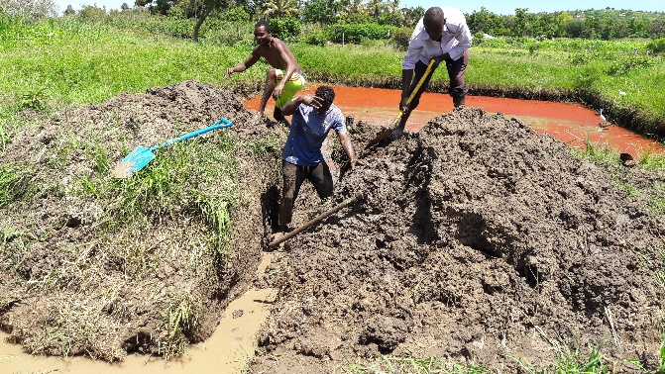

Fish Farming was born in Rusinga Island of Hope-Humanist
Raising Fish to support the Orphanage
With the simple visit to Mfangano Island, last 2017, by the Cooperators and donors from Czech and Slovak Republics, created the idea of doing fish farming project in Rusinga Island of Hope Center-Humanist.
The team meet Mr. Ronaldo B. Gitana an Aquaculture Expert from the Philippines, who is doing fish farming in the said Island. He is a graduate of Fisheries in one of the Leading Fishery School in the Philippines which is Bicol University College of Fisheries. He graduated in 1986. Since then he is practicing Fish farming. He worked in several countries, namely India, Mozambique, Vietnam, Zambia, Zimbabwe, and Malaysia.
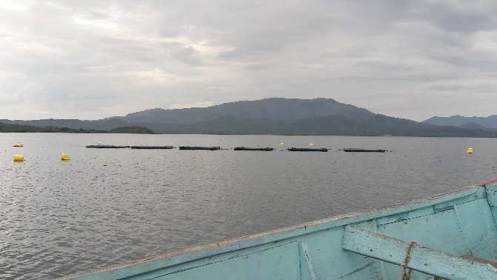
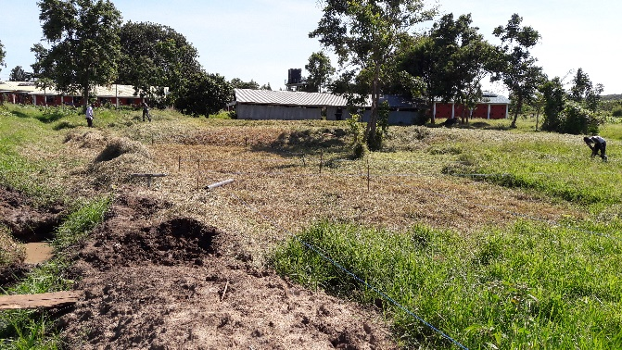
The project started last Jan. 26, 2018. Started the repairs and improvement of the existing 2x2m fish cage and fabricated 6 units 6x6 m. fish cages. Also improved the existing 2 ponds which was used initially to rear the future breeders of the Fish Hatchery.
Construction of ponds and improvent of the existing 2 ponds
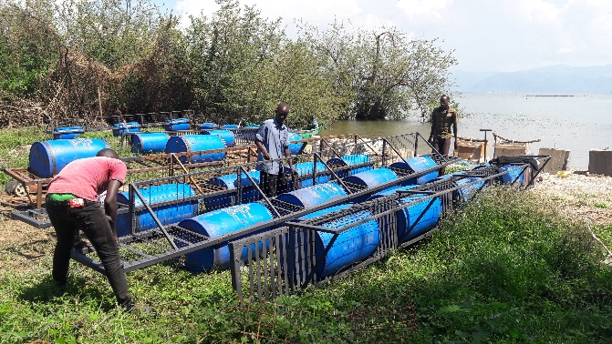
Fabrication of 6x6m, steel fish cage frame

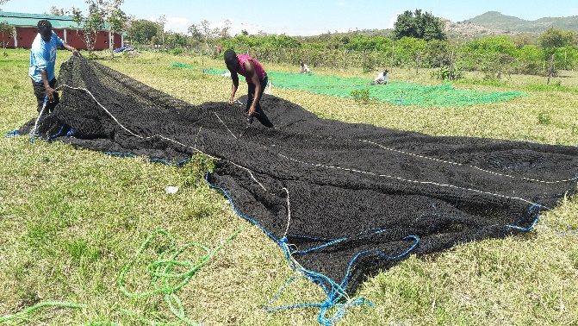
Stitching of the fish cage nets
The newly installed 2x2m existing fish cages
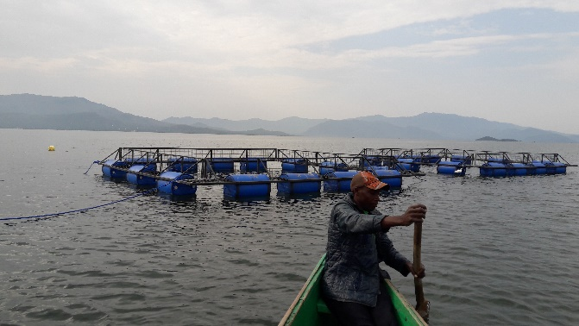
Installed the new 6x6 m. fish cages
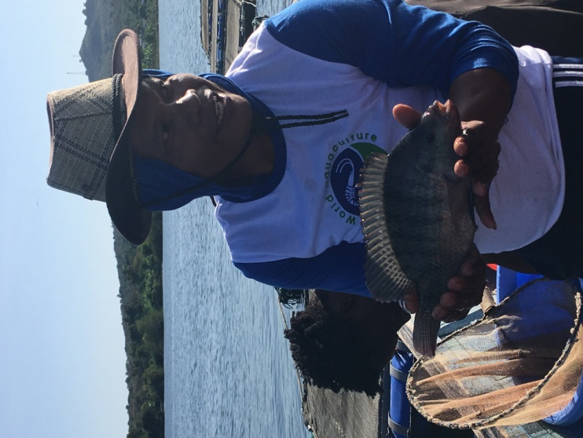
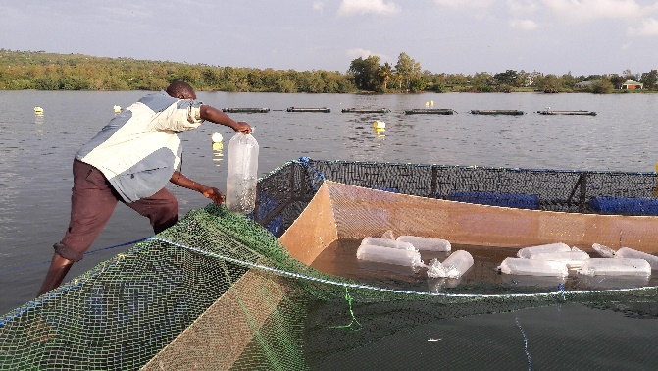
Stocking of tilapia fingerlings started last March 2018
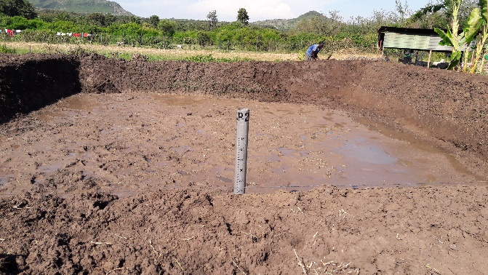
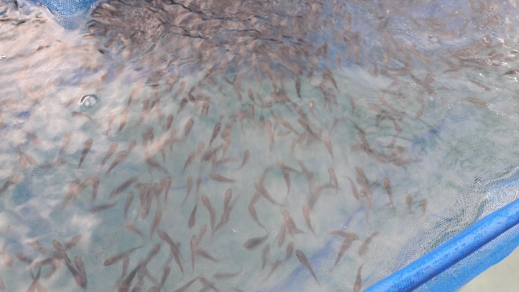
The tilapia finegrlings we stocked in the fish cages
The newly constructed pond for breeding the tilapia

For the first two months works were hectic to catch up the schedule of fabrication and installation of the fish cages. All the six units were finished on time and stocked as schedule.
After 9 months of hard work. We started harvesting the small cages, and seen the fruit of our labor.
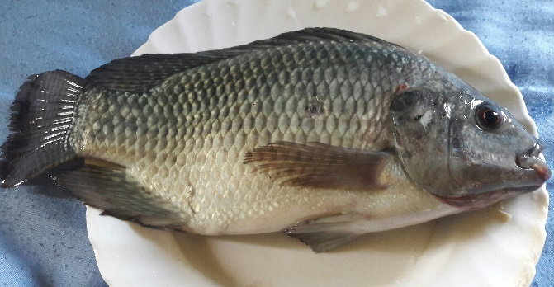
As of this time we finished harvesting the 4th fish cage. And slowly but surely establish the local market for our Humanist Fish for All brand-fresh from the lake with premium and yummy taste.
Mr. Ronaldo B. Gitana

